**ACTIVITIES-06:**

1. Write a program to display random number list in diagonal pattern before each number display 5 milliseconds wait then display number.

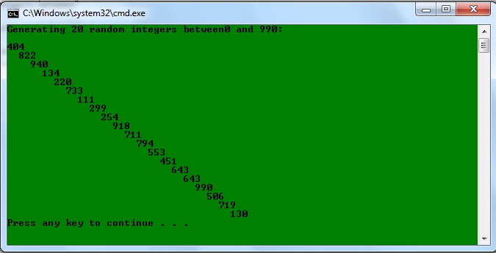

1. Write a program enter any number to display in integer, hexadecimal and binary also display all registers values.

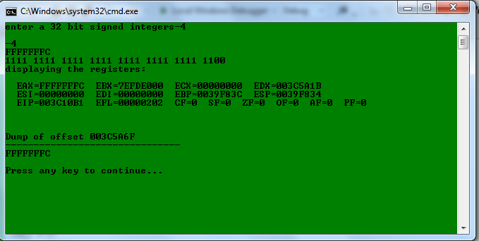

1. Write a program to display ‘enter user name’ after enter name,display ‘Hello name’

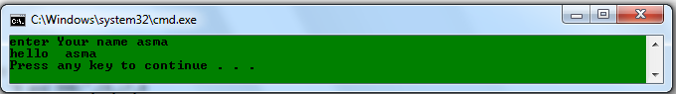

1. Write a program to take input data for an employee and store it in appropriate variables. The program should ask for Employee ID, Name, Year of Birth & Annual Salary from the user. The program should then calculate the annual tax on that employee’s annual salary if it exceeds Rs. 50,000 and display the message tax is calculated in a message box. The tax is calculated according to formula:

*Tax = Monthly Salary / 2*

1. ENTER A NUMBER IN DECIMAL,GENERATE ITS TABLE

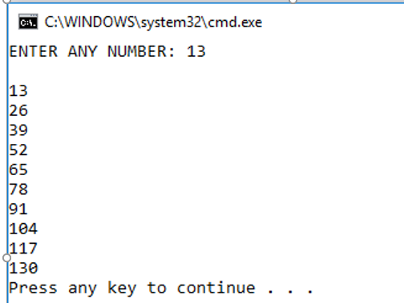

1. WRITE A CHARACTER IN SMALL OR CAPITAL ALPHABET , CONVERT IT TO ITS EQUIVALENT ALBHABET.

IF ITS IN CAPITAL LETTER CONVERT TO SMALL AND VICE VERSA.

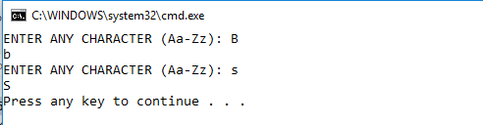

1. Print the following pattern (using GotoXY and any other library procedure) without using the “Space" character.

*

**

***

****

*****